Investiture badges; The badges we give you when you join the group and get invested

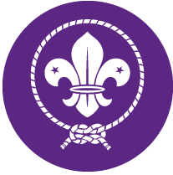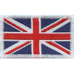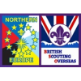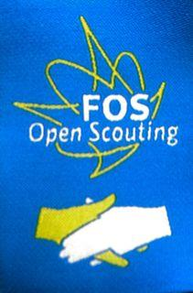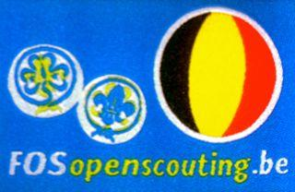

Plus the green 1st Brussels and blue Vlaams-Brabant name-tapes.

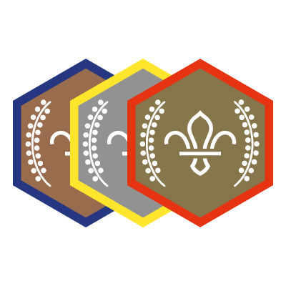
Chief Scout Award’s; Getting your Chief Scout awards is a big achievement in every section and you can wear this on your uniform in the next section, but only until you get your next Chief Scout award! If you didn’t quite get your Chief Scout award finished, let your new leaders know, as you can finish it in the first few weeks of your new section

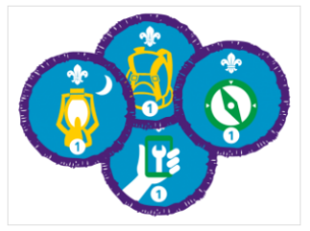
Staged Badges; The staged badges (the blue ones with purple edges) follow you throughout your time as a Scout these can be worn on Squirrel, Beaver, Cub, Scout or Explorer uniforms. Once you complete one award, you can start working towards the next one. You wear the highest award for each staged activity badge on your uniform. The level of the award is shown as a number at the bottom of the badge.

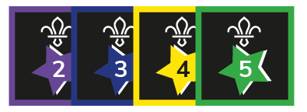
Joining-In Award; The joining-in award, is awarded on the anniversary of you joining The Scouting Movement. Take only the most recent award from your previous uniform and add it to the next, older badges can be sewn onto a camp blanket

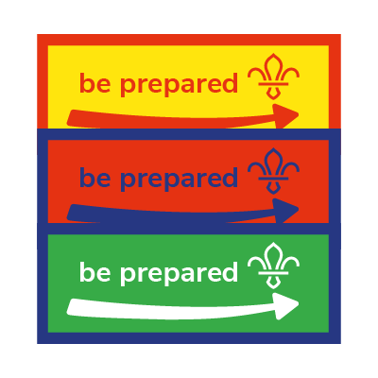
Moving on Award ; This is awarded to members who have moved up from the previous section when they are invested in their new section.

Please keep your Blue and Yellow Brussels neckerchief!
We give you ONE child size necker free when you are first invested as a Squirrel, Beaver or Cub. When you move up to Scouts you receive an adult size necker.
If you swap or lose your necker at any point, please arrange to buy a new one.

